**Assignment: Network Security Tools - Nikto, Nmap, and Wireshark**

**Introduction**

Network security tools play a crucial role in identifying vulnerabilities, mapping network infrastructure, and monitoring network traffic. This assignment focuses on three essential tools: Nikto, Nmap, and Wireshark.

**Nikto**

**Overview**

Nikto is an open-source web server scanner designed to perform comprehensive tests against web servers for multiple items, including dangerous files, outdated server software, and other potential security risks.

**Application**

* **Vulnerability Scanning:** Use Nikto to scan a target web server for vulnerabilities.
* **Results Analysis:** Interpret and analyze the results generated by Nikto to identify potential security issues.

**Screenshot:** 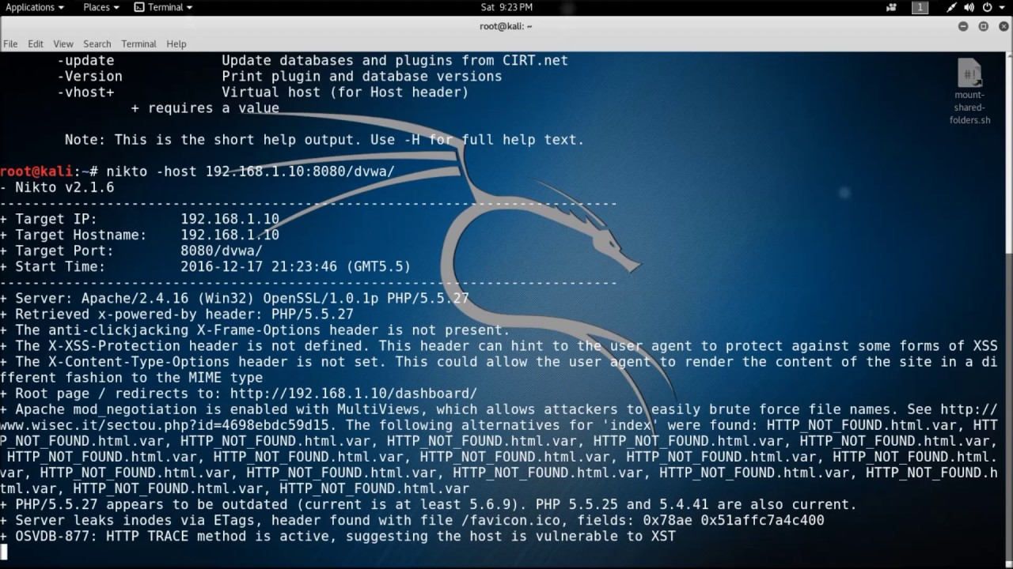

**Nmap**

**Overview**

Nmap (Network Mapper) is a powerful open-source tool for network exploration and security auditing. It can discover hosts, services, and open ports on a network.

**Application**

* **Host Discovery:** Use Nmap to discover live hosts on a given network.
* **Port Scanning:** Perform a port scan on a specific host to identify open ports and services.
* **Service Version Detection:** Utilize Nmap to determine the versions of services running on open ports.

**Screenshot:**

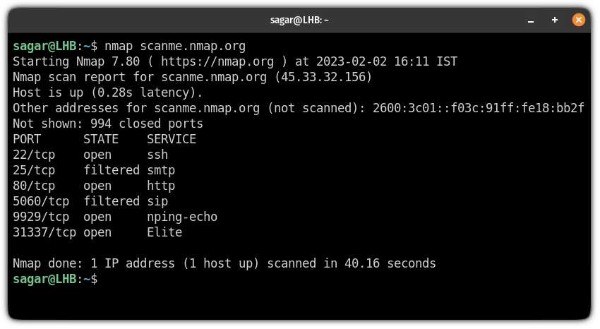

**Wireshark**

**Overview**

Wireshark is a widely-used network protocol analyzer that captures and displays the data traveling back and forth on a network in real-time.

**Application**

* **Packet Capture:** Use Wireshark to capture packets on a specific network interface.
* **Traffic Analysis:** Analyze captured packets to identify network activity, potential security threats, and abnormal behavior.

**Screenshot:** 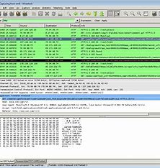

**Conclusion**

In conclusion, Nikto, Nmap, and Wireshark are powerful tools that serve distinct purposes in network security. Through vulnerability scanning, host discovery, and packet analysis, these tools contribute to maintaining a secure network environment.

Remember to replace the placeholder text with actual links to the screenshots. You can capture the screenshots while using these tools and upload them to a cloud storage service (like Google Drive or Dropbox) to obtain shareable links.